Answers are located Below
Question 3.54

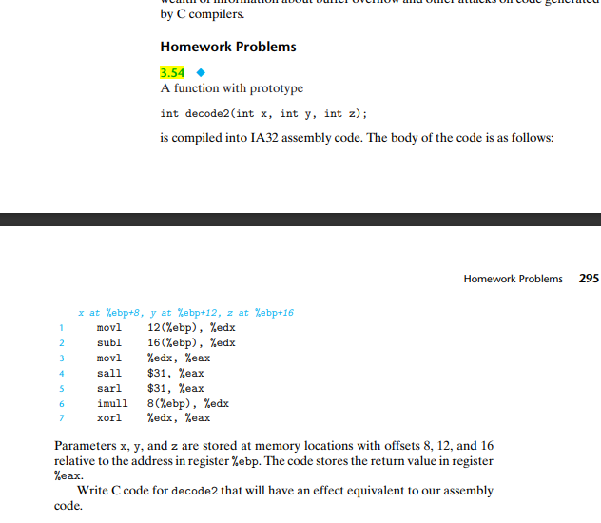

Question 3.56
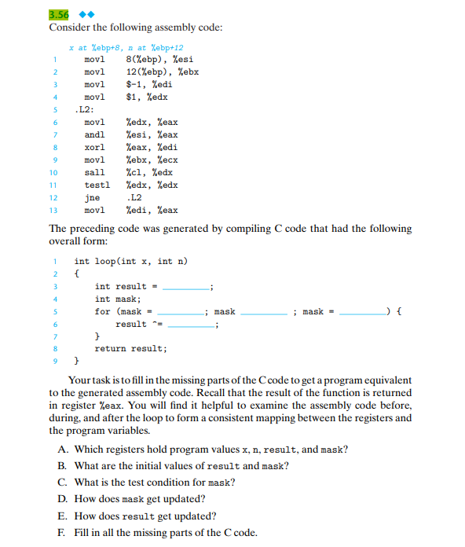

Question 3.59
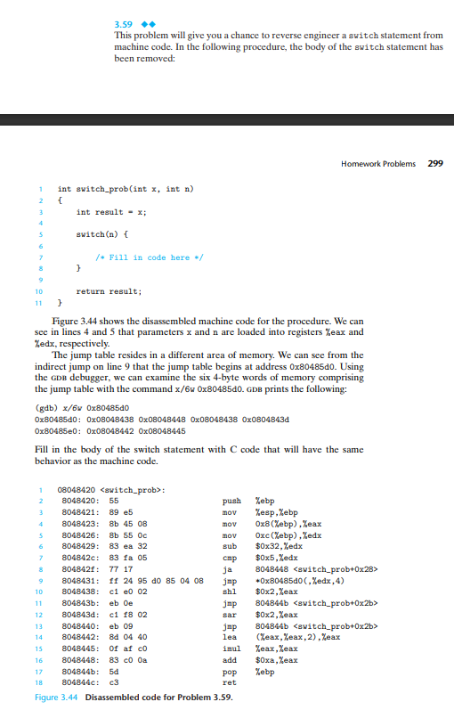

Question 3.62
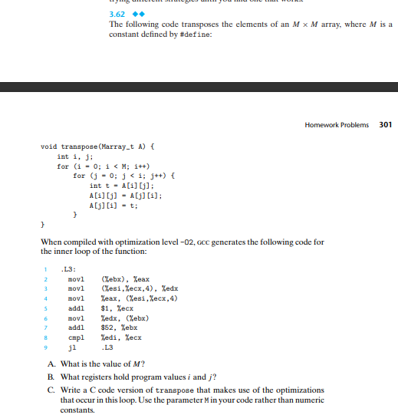
Question 3.64
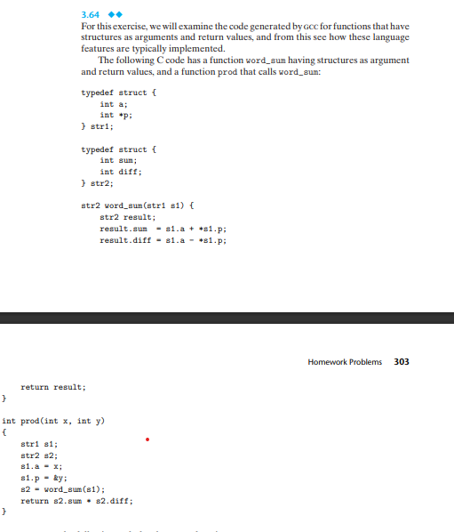
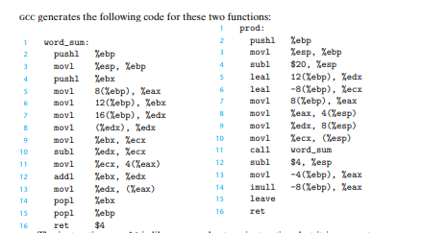
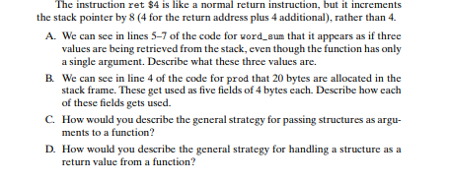

Answers:
3.54
int decode2(int x, int y, int z) {
int mult = 0, sub = 0, result = 0;

sub = y – z; // This line of code is equivalent to the first two lines provided we are subtracting.
result = sub; //is equivalent to the third line of the assembly where we are moving
result << = 31; //equivalent to the 4th line in which we do a left shift.
result >> = 31; //equivalent to 5th line where we do a right shift
mult = x * sub; //line 6 where we use the imul operator, one of the operands is subtracted while the other is for multiplication and the result of this will be stored in edx
result ^= mult; equivalent to line 7
return result;
}

3.56
int loop(int x, int n) {
int result = -1;
int mask;
for (mask = 1; mask != 0; mask = mask << n) {
result ^= (x & mask);
}
return result;
}

- we see the result be registered to edi, since the value gets copied to eax at the end of the return value. Continuing we can see that esi and ebx are loaded with the values of x and n leaving edx to hold one variable mask.
x : %esi
n : %ebx
mask :%edx
result :%edi
B. initial values of result is the Register %edi which is initialized to -1 and mask is %edx which is 1. Result is -1, mask is 1
C. The test condition for the mask is continuing the loop which is why mask is !=0
mask != 0;
D. Mask gets updated by the shift instruction which updates the mask to be mask << n.
E. result gets updated to be result ^= (x & mask);.
F. Code has been filled above.

3.59
Answer:
int switch_prob(int x, int n) {
int result = x;
switch(n) {
case 32: // code is executed if n = 32
case 34: // code is executed for n = 34
result <<= 2;
break; //switch statement terminates and jumps to the next line.
//following switch statement.
case 35: //code is executed if n = 35
result >>= 2;
break; //switch statement terminates and jumps to next line
case 36: //code is executed for n = 36
result *= 3;
case 37: //code is executed for n =37
result *= result;
default: // code will be executed if n does not match any cases
result += 0xa;
}
return result;
}

3.62
A. The value of M is 13
B. The program values of I and j are held in the registers edi and ecx.
C.
void transpose(int Marray_t[M], A[M]) {
int i, j;
for (i= 0; I < M; i++)
int t = A[i][j];
A[i][j] = A[j][i];
A[j][i] = t
}
}

3.64
A. The three values we see in lines 5-7 are line five shows the results. While line 6 shows s1.p and line seven shows s1.a. The description for this we can see by movl(%edx), %edx; which takes the address operation and corresponds to *s1.p, we can also see that 12(%ebp) corresponds to s1.p due to the structure relationship of str1, from this we can deduce that 16(%ebp) corresponds to s1.a
8(%ebp) = %eax :result
12(%ebp) = %ebx : s1.p
16(%ebp) = %edx :s1.a
B. The following fields are described below
s.2prod uses -4(%ebp)
s2.num uses -8(%ebp)
s1.p uses -12(ebp)
s1.v uses -16(%ebp)
&s2 uses -20(%ebp)

C. The assembly code provided by word sum. The general strategy for this question is to pass the values of the members of the structured parameters to the function as a parameter.
D. The instruction ret will return the value that is stored in the memory which is pointed by %eax. Then by looking at the assembly code for word_sum, we can see that %eax stores the address of the structure result. Furthermore, we can see the operation used movl %edx, (%eax) which is assigned to the address and with the value being stored in %eax. This results in the function returning the address of the structure variable.

